**MINI PROJECT**

# ON

**Arduino based Vacuum cleaner robot**



**DEPARTMENT OF INFORMATION TECHNOLOGY VASANTDADA PATIL PRATISHATHAN’S COLLEGE OF ENGINEERING AND**

**VISUAL ARTS MUMBAI UNIVERSITY 2023-24**

**Mini Project Report**

**ON**

**Arduino based Vacuum cleaner robot**

Submitted in partial fulfilment of the requirements of the requirements for the degree of Bachelor of Engineering in

Information Technology Semester-VI

By

|  |  |  |
| --- | --- | --- |
| No. | Name | ID No. |
| 1 | Sanket Zore | VU4S2223020 |
| 2 | Prathamesh Patil | VU4S2223025 |
| 3 | Omkar Bhoir | VU4S2223033 |
| 4 | Karan Vishwakarma | VU4S2223028 |

Under the Guidance

of

**Mrs. Nita Ingale**



Department of Information Technology

Vasantdada Patil Pratishthan's College of Engineering & Visual Arts

UNIVERSITY OF MUMBAI

(AY 2023-24)

**CERTIFICATE**

This is to certify that the project entitled “**Arduino based Vacuum cleaner robot”**

is a bonafide work of Sanket Zore (VU4S2223020), Prathamesh Patil (VU4S2223025), Omkar Bhoir (VU4S2223033), Karan Vishwakarma (VU4S2223028) submitted to University of Mumbai in partial fulfilment of requirement for the award of degree of **“Bachelor of Engineering in Information Technology – Semester VI”**

**Mrs. Nita Ingale**

Guide

Dr. Pradip Mane Dr. Alam N. Shaikh

Head of Department (IT) Principal & Campus Director

# Project Report Approval for T.E.

This project report entitled **“Arduino based Vacuum cleaner robot”** by Sanket Zore, Prathamesh Patil, Omkar Bhoir, Karan Vishwakarma is approved for the degree of **Bachelor of Engineering** in **Information Technology**.

Examiners

1.

2.

Date:

Place: Mumbai – 400022

Submitted by:

By

|  |  |  |
| --- | --- | --- |
| No. | Name | ID No. |
| 1 | K Suryanarayan Dora | VU4F2122034 |
| 2 | Soham Patil | VU4F2122022 |
| 3 | Bhavesh Madhavi | VU4F2122023 |
| 4 | Shubham Karande | VU4F2122037 |

## ABSTRACT

In the current hectic schedule, cleaning houses and surrounding environment is more arduous. At present, there are vacuum cleaners which require humans to handle it. Thus, there is a need to implement vacuum cleaner which works without human intervention.

An efficient method to clean the desired area has been implemented through this project. By using this vacuum cleaner, hazardous places can be cleaned which thereby reduce risks to mankind. This is achieved by implementing an autonomous system.

The main objective of this project is to design and implement a vacuum robot prototype by using Arduino uno, Motor shield, Ultrasonic sensor and motor with wheels to achieve the goal of this project.

The ultrasonic sensor is used to measure the distance between robot and obstacle. The whole circuit is connected with 9V+9V+9V+9V battery. Vacuum robot will have several criterial that are user-friendly.

**Keywords:**

* Arduino uno
* Ultrasonic Sensor
* Servo Motor
* Jumper wires male to female
* Motor shield
* Laptop/pc

**ACKNOWLEDGEMENT**

I express my gratitude to **Mrs. Ashwini Phalke-Mulik** for his help, guidance throughout the work for this project without which we would not have been able to complete this project to such a success.

I would also like to thank my class mates who helped me directly or indirectly in accomplishing this task and also to my group mates who were with me all this time throughout the project.

Finally, I would also like to thank other faculty members who provided us with moral support during the course of this project.

# CONTENTS

|  |  |  |  |  |
| --- | --- | --- | --- | --- |
| **CHAPTER NO** | | | **NAME OF CHAPTER** | **PAGE NO.** |
| **1** |  |  | **INTRODUCTION** |  |
| 1.1 |  | INTRODUCTION DESCRIPTION | 9 |
| **2** |  |  | **LITERATURE REVIEW** |  |
| 2.1 |  | EXISTING SYSTEM | 10 |
| 2.2 |  | LIMITATION OF EXISITING SYSTEM AND RESEARCH GAP | 11 |
| 2.3 |  | PROBLEM STATEMENT AND OBJECTIVE | 12 |
| 2.4 |  | SCOPE | 13 |
| **3** |  |  | **PROPOSED SYSTEM** |  |
| 3.1 |  | DETAILS OF HARDWARE AND SOFTWARE | 15 |
| 3.2 |  | DESIGN DETAILS |  |
| 3.2.1 | SYSTEM ARCHITECTURE | 17 |
| 3.2.2 | FLOW CHART | 18 |
| 3.3 |  | METHDOLOGY/PROCEDURES | 19 |
| 3.4 |  | RESULT AND DISCUSSIONS | 20 |
|  | 3.4.1 | RESULTS, DISCUSSION- COMPARATIVE STUDY/ ANALYSIS | 21 |
| **4** |  |  | **CONCLUSION** | 21 |
| **5** |  |  | **REFERNCES** | 22 |

**List of figures**

|  |  |  |
| --- | --- | --- |
| **Sr No.** | **Name of the figure** | **Page no.** |
| 1 | **Arduino UNO** | **14** |
| **2** | **Ultrasonic Sensor** | **15** |
| **3** | **Bluetooth Module** | **16** |
| **4** | **Circuit Diagram** | **19** |
| **5** | **Flowchart** | **21** |
| **6** | **Results** | **23** |

# 1. INTRODUCTION

An Arduino-based vacuum cleaner is a cleaning device that is powered and controlled by an Arduino microcontroller. The Arduino board is programmed to control the motors, sensors, and other components that make up the vacuum cleaner. This allows for a high degree of customization and control over the cleaning process, making it possible to program the vacuum cleaner to clean specific areas, adjust the suction power, and even navigate around obstacles. Additionally, an Arduino-based vacuum cleaner can be connected to other devices and systems, such as a smartphone or a home automation system, to provide remote control and monitoring capabilities. This makes the vacuum cleaner not only a practical cleaning tool, but also a fun and educational project for makers and hobbyists interested in robotics and home automation.

A vacuum cleaner, commonly referred to as a vacuum or a hoover, is a machine that creates suction to take dirt off of surfaces like floors, couches, draperies, and other objects. Typically, electricity is used to power it. Either a dust bag or a cyclone collects the dirt for subsequent disposal. Small battery-powered hand-held vacuum cleaners, wheeled canister models for home use, domestic central vacuum cleaners, enormous stationary industrial machines that can hold hundreds of liters of dirt before being emptied, and self-propelled vacuum trucks for cleanup of significant spills or removal of contaminated soil are all different sizes and models of vacuum cleaners that are used in both homes and industry. Both solid objects and liquids can be sucked up using specialized shop vacuums.

An obstacle avoidance robot is an autonomous robot that can move through its environment and avoid obstacles in its route without any human involvement. It is outfitted with sensors that identify obstacles in its path and algorithms that allow it to decide how to avoid them. The robot can be built to work in a range of conditions, from straightforward inside settings to challenging outdoor terrains. As they can travel through unfamiliar environments and avoid potential dangers, these robots are frequently utilised in applications including surveillance, exploration, and transportation.

# 2. LITERATURE REVIEW

**2.1 EXISTING SYSTEM**

"Design and Implementation of a Low-Cost Ultrasonic Radar System for Object Detection" by D. Macias and A. Molina:

This paper presents a low-cost ultrasonic radar system for object detection using an array of ultrasonic sensors. The system is designed for use in small robotics applications and is able to detect objects within a range of several meters. The authors demonstrate the effectiveness of the system in various experimental settings.

"Design of Ultrasonic Radar System for Vehicle Obstacle Detection" by K. T. Kim et al.:

This paper describes the design of an ultrasonic radar system for vehicle obstacle detection. The system employs an array of ultrasonic sensors and a microcontroller to detect obstacles and provide visual and audible warnings to the driver. The authors showcase the system's effectiveness in experiments involving various obstacles and vehicle speeds.

"Object Detection Using Ultrasonic Sensor with Robot Navigation" by R. G. Mishra et al.:

This paper introduces a system for object detection and robot navigation using an ultrasonic sensor. The system utilizes a microcontroller to process sensor data and calculate distances to nearby objects. The authors present the system's effectiveness in experiments with different obstacle configurations and robot speeds.

"Ultrasonic Sensing for Autonomous Vehicles: A Review" by M. Yang et al.:

This paper offers a review of ultrasonic sensor applications for object detection in autonomous vehicles. The authors discuss ultrasonic sensor advantages and limitations compared to other sensor types, providing examples of ultrasonic sensor usage in existing autonomous vehicle systems.

**2.2 LIMITATION OF EXISTING SYSTEM AND RESEARCH GAP**

Limited Range:

One significant limitation of ultrasonic sensors is their restricted range compared to radar or lidar sensors. While they are effective for close-range sensing, their capabilities diminish as the distance increases. This limitation restricts their suitability for applications requiring long-range object detection or navigation.

Interference Sensitivity:

Ultrasonic sensors are sensitive to environmental factors such as ambient noise and vibrations. This sensitivity can lead to interference, resulting in inaccurate readings or false detections. In environments with high levels of background noise or vibration, the reliability of ultrasonic sensors may be compromised, affecting the overall performance of the system.

Placement Dependency:

The effectiveness of ultrasonic sensors is highly dependent on their placement and orientation within the environment. Incorrect placement or orientation can lead to suboptimal performance and reduced accuracy in object detection. Ensuring proper alignment and positioning of ultrasonic sensors is crucial to maximizing their effectiveness and minimizing potential blind spots or coverage gaps.

Cost Considerations:

While ultrasonic sensors are generally more affordable than radar or lidar sensors, their cost and complexity may still present challenges for some applications. The need for multiple sensors to cover larger areas or achieve desired detection accuracy can increase overall system costs. Additionally, the integration of ultrasonic sensors into complex systems may require additional hardware and software components, adding to the overall complexity and cost of the solution. Thus, while cost-effective compared to alternative sensing technologies, cost considerations remain a factor to be addressed in the design and implementation of systems utilizing ultrasonic sensors.

**2.3 PROBLEM STATEMENT AND OBJECTIVE**

Existing object detection systems often rely on costly sensors like radar or lidar, making them inaccessible for certain applications. Moreover, ultrasonic sensor-based systems face challenges such as limited range and interference, impacting their accuracy and efficacy. Hence, there's a demand for a cost-effective yet accurate object detection solution employing ultrasonic sensors across diverse environments.

In this project, we aim to implement a straightforward Arduino-based object detection system utilizing radar principles. Our objectives include:

Designing and deploying a prototype object detection system using ultrasonic sensors.

* Optimizing sensor placement and orientation to maximize accuracy and detection range.
* Developing algorithms and signal processing techniques to mitigate interference and enhance accuracy.
* Conducting thorough testing in various environments, both indoor and outdoor, with diverse obstacles.
* Comparing the performance of our ultrasonic sensor-based system with existing radar or lidar systems, focusing on accuracy, range, and cost-effectiveness.
* Exploring potential applications for the system, such as autonomous vehicles, robotics, and parking sensors.
* Identifying potential areas for further research and development in the realm of ultrasonic sensor-based object detection.

**2.4 SCOPE**

**The scope of the project encompasses:**

Developing a low-cost, accurate object detection system using ultrasonic sensors for diverse applications, including robotics, vehicle safety, and parking sensors.

Optimizing sensor placement and orientation for maximum accuracy and range.

Developing algorithms and signal processing techniques to mitigate interference and enhance accuracy.

Integrating the sensor system with a microcontroller or computing device for real-time data processing.

Testing the sensor system across various environments and obstacle types.

Comparing the performance of the ultrasonic sensor-based system with radar or lidar systems in terms of accuracy, range, and cost.

Exploring potential applications such as autonomous vehicles, robotics, and parking sensors.

Documenting the design, development, and testing process, including hardware specifications, wiring diagrams, and code.

Identifying areas for further research and development in ultrasonic sensor-based object detection.

**3. PROPOSED SYSTEM**

An Arduino-based vacuum cleaner is a cleaning device that is powered and controlled by an Arduino microcontroller. The Arduino board is programmed to control the motors, sensors, and other components that make up the vacuum cleaner. This allows for a high degree of customization and control over the cleaning process, making it possible to program the vacuum cleaner to clean specific areas, adjust the suction power, and even navigate around obstacles. Additionally, an Arduino-based vacuum cleaner can be connected to other devices and systems, such as a smartphone or a home automation system, to provide remote control and monitoring capabilities. This makes the vacuum cleaner not only a practical cleaning tool, but also a fun and educational project for makers and hobbyists interested in robotics and home automation.

* **Efficiency**: Enhance cleaning processes by automating tasks to achieve thorough and timely cleaning coverage.
* **Adaptability**: Develop a robot capable of navigating diverse environments and adjusting cleaning patterns to overcome obstacles.
* **Accessibility**: Provide a user-friendly interface and ergonomic design to make cleaning tasks accessible to all users, regardless of physical limitations.
* **Cost-effectiveness**: Offer a cost-effective alternative to traditional cleaning services, minimizing both initial investment and ongoing maintenance expenses.
* **Customization**: Enable easy customization of cleaning techniques and schedules to suit various environments, ensuring optimal performance in different settings.

## DETAILS OF HARDWARE AND SOFTWARE

* + 1. **ARDUINO UNO:**

The Arduino Uno is a microcontroller based on AT mega 328, which is having 14 digital input/output pins, six analog input pins, a USB connection facility, a power jack and a reset button facility.

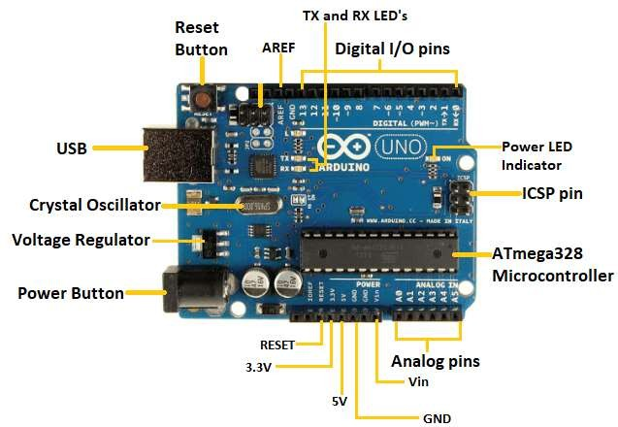

## ULTRASONIC SENSOR:

Ultrasonic sensors measure the distance by using ultrasonic waves by which the sensor head emits an ultrasonic wave, i.e., the transmitter head, and the receiver absorbs the wave from the reflected target back. Ultrasonic sensors measure the distance between the emission and the receiving time of the target.

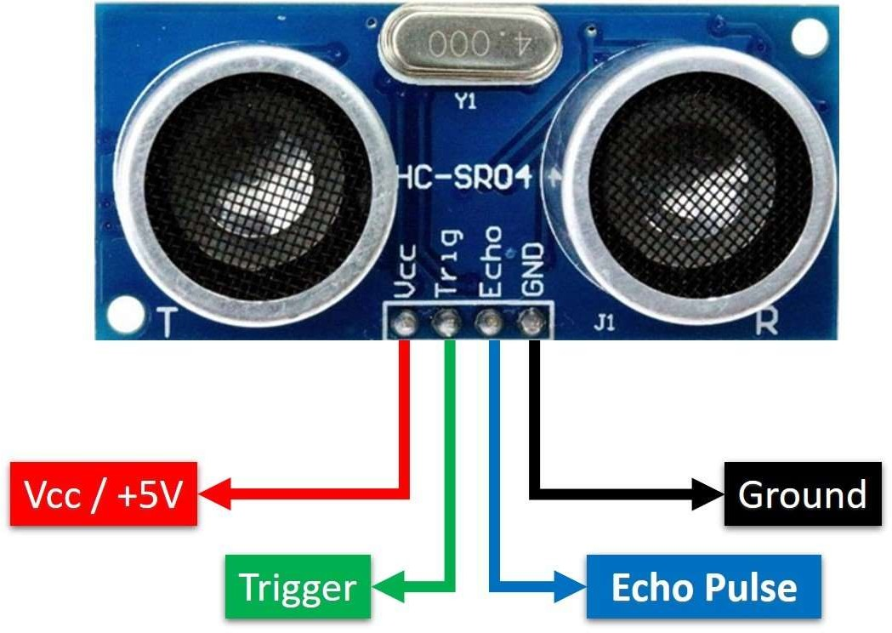

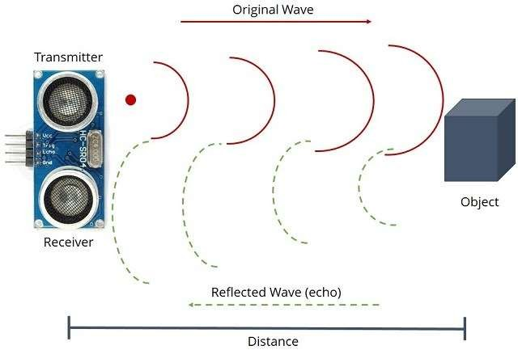

## BLUETOOTH MODULE:

HC-05 has a red [light emitting diode](https://www.sciencedirect.com/topics/computer-science/light-emitting-diode" \o "Learn more about light emitting diode from ScienceDirect's AI-generated Topic Pages) (LED), which indicates the connection status with the Bluetooth. Before connecting to the HC-05 module the red LED blinks continuously in a periodic manner. When it gets connected to any other [Bluetooth device](https://www.sciencedirect.com/topics/computer-science/bluetooth-device" \o "Learn more about Bluetooth device from ScienceDirect's AI-generated Topic Pages), its blinking slows down to two seconds. This module works on 3.3 V. We can connect 5 V [supply voltage](https://www.sciencedirect.com/topics/computer-science/supply-voltage" \o "Learn more about supply voltage from ScienceDirect's AI-generated Topic Pages) as well since the module has a 5–3.3 V regulator on the board. As HC-05 Bluetooth module has a 3.3 V level for receiving/transmitting (RX/TX), and the [microcontroller](https://www.sciencedirect.com/topics/computer-science/microcontroller" \o "Learn more about microcontroller from ScienceDirect's AI-generated Topic Pages) can detect a 3.3 V level.

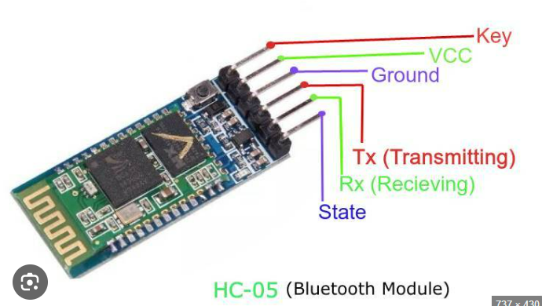

## 3.2 DESIGN DETAILS

* + 1. **SYSTEM ARCHITECTURE**

The system would use multiple ultrasonic sensors to detect objects in the environment. The sensors would be mounted on the vehicle or robot in a way that maximizes the field of view and range of the sensors.

Once the system is turned on, the Arduino is powered by a power source, and the vehicle moves using a motor driver and caster wheel until an obstacle is detected. If an obstacle is detected, the robot changes its direction using the motor driver and program that has been loaded into the Arduino. The robot continuously changes its direction as it moves through the area it covers the entire space of the room. During the movement of the robot the vacuum cleaner is also turned on. The vacuum cleaner picks up the dust particles and cleans the area it moved

The robot has the following design:

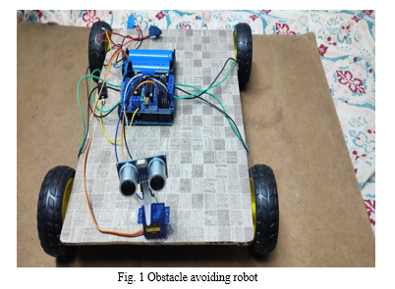

The robot is supported on a wooden board as shown in figure 1. The required rectangular shape is created by cutting the board. The hardwood board's sides and edges are smoothed off by grinding. At this point, glue is used to secure the geared motor wheels in place at the bottom of the board. As seen in the illustration, the Arduino UNO is mounted on the motor shield. According to the code provided to Uno through the Arduino IDE software, the motor shield controls all the motors and wheels that are wired to it.

Over the servo motor, an ultrasonic sensor is mounted. This sensor identifies any obstructions in the robot's path and allows it to avoid collisions that could harm it. It is the robot's front that the servo motor is mounted on. The motor shield's slots are occupied by the pins of the servo motor and the ultrasonic sensor, respectively.

The lithium ion battery, which is mounted on the robot's back side, powers the entire circuit. The robot can be turned on and off whenever necessary using a switch.

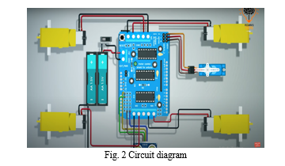

All connections are done in accordance with the circuit schematic above as shown in figure 2.

The code for an Arduino-based vacuum cleaner is written in the Arduino Integrated Development Environment (IDE) using the C++ programming language.

The Arduino IDE is a software platform that allows you to write, upload, and run code on the Arduino board. To start programming an Arduino Uno, you need to connect it to your computer via USB and open the Arduino IDE as shown in figure 3.

The vacuum cleaner is prepared as shown in the figure. The process of the vacuum cleaner is preparation is done as follows:

1. The bottle's bottom is first chopped off with a knife to be removed.
2. The bottle-shaped portion of a fine mesh is cut. Now wrap the net over a cardboard piece that was given a bottle-diameter cut out.
3. Attach both the cardboard piece and the net. In the bottle, place the net arrangement.
4. After putting the filter in place, take the 6V motor and, using the wooden sticks as supports, put it inside the bottle.
5. Fix the fan to the motor.
6. The bottle opening has a T-shaped aperture attached to it to extend the suction area, which allows it to clean a larger area.

It is provided with a 9V+9V+9V The system would use multiple ultrasonic sensors to detect objects in the environment. The sensors would be mounted on the vehicle or robot in a way that maximizes the field of view and range of the sensors.

## FLOW CHART

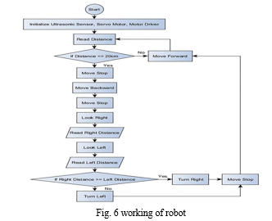

According to the flowchart above, as soon as the robot is turned on, an ultrasonic sensor measures the space in front of it. If the distance is less than 20 cm, the robot stops moving, and it moves backward while the servo motor rotates at an angle to measure the space on the robot's right and left sides. The robot goes in that direction if the distance is larger than 20 cm, and the process is repeated if the robot encounters any impediments. The vacuum cleaner is turned on at the same time as the robot. The vacuum cleaner cleans the area by sucking up all the dust particles, bits of paper, and other undesired things.

## METHODOLGY /PROCEDURES

• Gear motor with wheels:

* **Gear motor with wheels**

The Gear motor with wheels main purpose is to allow the reduction from an initial high speed to a lower one without negatively affecting the mechanism. In addition to this

adjustment, a gear motor is in charge of adjusting the mechanical power of a system.

• Motor Driver:

* **Motor driver**

A motor driver takes the low-current signal from the controller circuit and amps it up into a high-current signal, to correctly drive the motor. It basically

controls a high-current signal. using a low-current signal.

* **Arduino UNO**

• Arduino Uno:

Arduino UNO is a low-cost, flexible, and easy-to-use programmable open-source microcontroller board that can be integrated into a variety of electronic projects.

This board can be interfaced with other Arduino boards, Arduino shields, Raspberry Pi boards and can control relays, LEDs, servos, and motors as an output.

* **Servomotor**

• Servo motor :

A servomotor (or servo motor) is a rotary actuator or linear actuator that allows for precise control of angular or linear position, velocity, and acceleration. It

consists of a suitable motor coupled to a sensor for position feedback.

* **Ultrasonic sensor**

• Ultrasonic sensor:

The module has two eyes like projects in the front which forms the Ultrasonic transmitter and Receiver. The HC-SR04 ultrasonic sensor uses sonar to determine the distance to an object. This Ultrasonic Sensor module is a transmitter, a receiver, and a control circuit in one single pack.

• 6v motor

• Lithium–ion battery cell

**3.4. RESULT**

Following figure show the results of our design when the sensor rotates through the area and detects obstacle in the way and the vacuum cleaner sucks to remove dust and other substances from surfaces

**Testing of the system**

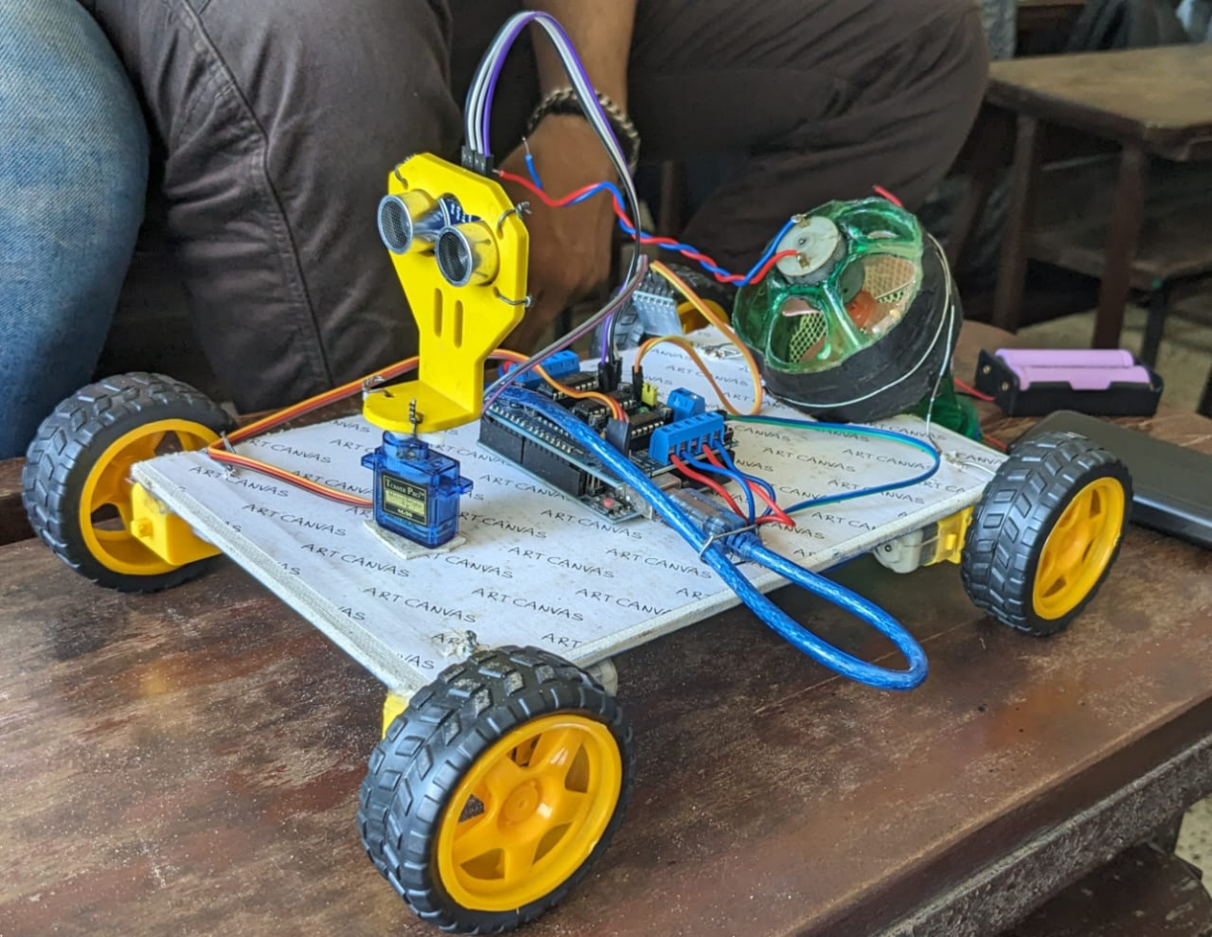

1. **CONCLUSION**

The use of a smart vacuum cleaner has been implemented in this project. It operated using pre-written code that was placed into an Arduino UNO. When an impediment is encountered, a Vehicle will turn to the side. When there is more space between the car and the obstruction. This invention uses a battery-powered vacuum cleaner and a axial fan connected to the 6v motor to collect dust without the need for human interaction, lowering the risks to human health.

This cleaner is easy to use and reasonably priced. However, since cleaning the dust becomes easier, utilising a detachable bag can be preferable. A lithium battery with an input power of 3.6 watts powers the vacuum cleaner that was created for this project. An anemometer measures the air velocity passing through the vacuum cleaner, while a pressure gauge measures the pressure inside the vacuum cleaner. The vacuum cleaner\'s effectiveness is 29.79%.

1. **REFERENCES**
2. Ajitha sukumaran, Sabrina “SMART VACUUM CLEANER” JSR Publishing house, Volume: 12, Issue: 2, ISSN: 2167-1907, June 2022
3. Yuda Irawan, Muhardi, Rian Ordila and Roni Diandra, "Automatic Floor Cleaning Robot Using Arduino a nd Ultrasonic Sensor", Journal of Robotics and Control (JRC), vol. 2, no. 4, July 2022.
4. Minimizing latency for multiple-type data aggregation in wireless sensor networks 2021 IEEE Wireless Communications and Networking Conference (WCNC), IEEE (2021), pp. 1-6
5. K. M. Chandra Babu and P. A. Harsha Vardhini, "Brain Computer Interface based Arduino Home Automation System for Physically Challenged", 2020 3rd International Conference on Intelligent Sustainable Systems (ICISS), pp. 125-130, 2020.
6. “DESIGN AND IMPLEMENTATION OF AN INTELLIGENT DUST CLEANER ROBOT FOR UNEVEN AND NONSTRUCTURAL ENVIRONMENT” International Conference on Computing, Mathematics and Engineering Technologies IEEE doi:10.1109/icomet.2019.8673450, April 2019.
7. ROBOTIC VACUUM CLEANER USING ARDUINO WITH WIFI” International Conference on Inventive Communication and Computational Technologies part number: CFP18BAC-ART; ISBN:978-1-5386-1974-2 April 2018